Haslemere Town
Council
EMERGENCY PLAN
October 2023
Haslemere Town Council
Town Hall, Haslemere High Street, GU27 2HG

Town Hall phone number: 01428 654305
Town Hall email: admin@haslemeretc.org
In the event of an emergency visit our website which will be kept up to date with further information www.haslemeretc.org

CONTENTS
INTRODUCTION 4
WHAT IS AN EMERGENCY? 4
THE AIM AND OBJECTIVES OF THE PLAN 4
ROLES AND RESPONSIBILITIES OF HASLEMERE TOWN COUNCIL 4
TOWN COUNCIL EMERGENCY COMMITTEE 5
TOWN COUNCIL EMERGENCY PLAN COORDINATORS 5
TOWN COUNCILLORS 5
TOWN COUNCIL EMERGENCY CONTROL CENTRE 5
TOWN COUNCIL RESPONSE ACTION and ACTIVATION ARRANGEMENTS 6
TOWN COUNCIL COMMUNICATION CASCADE 6
WHAT SORT OF EMERGENCY? 7
RESPONSIBILITIES IN AN EMERGENCY 9
ROLES AND RESPONSIBILITES OF KEY AGENCIES 11
CATEGORY ONE RESPONDERS (EMERGENCY SERVICES) 11
CATEGORY ONE RESPONDERS (OTHER) 12
CATEGORY TWO RESPONDERS (UTILITIES) 13
CONTACT NUMBERS 14
Resources to help residents plan and respond 15
Surrey Be Prepared 15
COMMUNICATIONS 15
GO IN, STAY IN, TUNE IN, 15
TEMPORARY ACCOMMODATION/REST CENTRES 16
HASLEMERE EMERGENCY SNOW PLAN 18
LOCATION OF GRIT BINS IN AND AROUND HASLEMERE 19
LOCATION OF SALT STOCKS 21
Pavement gritting – areas the responsibility of SCC - Haslemere 22
Pavement gritting – areas the responsibility of SCC – Beacon Hill 22
Location of Defibrillators in Grayswood, Haslemere and Hindhead 23

Version | DATE | Version | DATE
1.0 | March 2017 | 2.0 | February 2021
1.1 | November 2017 | 2.1 | July 2023
1.2 | February 2018
1.3 | May 2018
1.4 | March 2019
1.5 | May 2019

INTRODUCTION
This plan has been initiated by Haslemere Town Council in consultation with Waverley Borough Council and taking account of Surrey County Council’s Local Resilience Forum. In the event of an emergency occurring that impacts the Town Council area, there is clear understanding of the roles and responsibilities of the various support agencies, and any support Haslemere Town Council can offer. The plan also provides a communication cascade for information and potential assistance with recovery. It must be remembered that the first line of response must be from professional responders, depending on the emergency. If there is any risk to life at all Contact 999.

WHAT IS AN EMERGENCY?
The formal definition of an emergency in line with Civil Contingencies Act (2004) “an event or situation which threatens serious damage to human welfare, an event or situation which threatens serious damage to the environment.”

THE AIM AND OBJECTIVES OF THE PLAN
The plan has been designed to enable Haslemere Town Council to identify immediate actions which it must consider during an emergency. It provides a framework for assisting in the local response to an emergency, and aiding the continuation of local services. The objectives are:
- Providing a statement of the risks to the community and relevant response actions;
- Providing a framework to access local knowledge and expertise;
- Providing a framework to relay information and instructions to the local community; and
- Prioritising the availability of Council owned assets, including the Town Council Offices, for support during an emergency.

ROLES AND RESPONSIBILITIES OF HASLEMERE TOWN COUNCIL
Haslemere Town Council has no official role in respect of emergencies however it will be subject to public expectations as a community leader and owner of assets across the Town Council area. It may contribute to emergency response through assisting with:
- The dissemination of agreed warning and informing messages;
- The identification of vulnerable groups – e.g. elderly or disabled, where applicable;
- The distribution of emergency equipment from borough or county council stock piles, where applicable;
- The passing of information regarding local issues and needs to key responders, via the Borough Council.

TOWN COUNCIL EMERGENCY COMMITTEE
Town Mayor, Town Clerk, Chair of Amenities committee
The committee will:
- Establish a communications link with the Waverley Borough Council’s Emergency Planning Team and other Category One Responders as required.
- Assess what Town Council resources may assist responders in dealing with an emergency or incident.
- Agree the strategic response of Haslemere Town Council to any emergency or incident.
- Authorise any expenditure that may need to be incurred in dealing with the emergency or incident.

TOWN COUNCIL EMERGENCY PLAN COORDINATORS
Deputy Town Clerk, Support Services Officer, Office Administrator, Project & Amenities Officer
The town hall officers will:
- Receive strategic direction from the Emergency Committee and put an agreed response into operation
- Assist with the dissemination of warning and informative messages as directed by the Emergency Committee
- Following any emergency or incident assess and feedback the impact on the local community where possible
- To recruit suitable volunteers from local community to be trained as community emergency wardens.
- To liaise with Waverley Borough Council’s Emergency Planning Team (both in terms of planning for and training for incidents)

TOWN COUNCILLORS
In the event of an emergency, Town Councillors will be expected to:
- Receive and disseminate warning and informing messages as directed by the Emergency Committee or Emergency Plan Coordinators
- Assist the Emergency Plan Coordinators to identify suitable volunteers to be trained as community emergency wardens
- Be responsible for supporting vulnerable people in their wards as necessary.

TOWN COUNCIL EMERGENCY CONTROL CENTRE
The Town Hall, High Street, Haslemere, Surrey GU27 2HG – Tel no: 01428 654305.
Key Holders: Town Clerk, Deputy Town Clerk, Administrator and Project & Amenities Officer
In the event that the Town Hall cannot be accessed the Emergency Committee will identify another suitable venue and this information will be disseminated to all relevant parties and on the Council’s website.

TOWN COUNCIL RESPONSE ACTION and ACTIVATION ARRANGEMENTS
- The Emergency Duty Officer or Senior Manager at WBC will contact the Haslemere Town Clerk in the first instance who will assess the situation and decide whether to activate the Haslemere Town Council Emergency Committee
- Depending on the nature of the emergency or incident, the Town Council Communication Cascade will be used by telephone or email as required
- In an emergency the Town Council will call for citizens and equipment that might be able to help in an emergency, such as
- Human skills (doctors, nurses, HGV drivers)
- Materials (heavy plant, tractors, trailers and generators)
- Useful premises (commercial accommodation, barns and outbuildings).

TOWN COUNCIL COMMUNICATION CASCADE

Town Clerk/Town Mayor/Chair Amenities Emergency Committee

WBC/SCC Emergency contact
Town Hall staff Emergency plan
co-ordinators
All
Councillors
Stakeholder
groups
Haslemere Help
Volunteers

Social media
Website
Telephone
Affiliated organisations
Linked groups such as:
CAB
Chamber of commerce
Churches
Haslewey
Schools
Supermarkets

WHAT SORT OF EMERGENCY?
Types of potential emergencies which may affect Haslemere community include:

Scenario | Situation | Category 1 or 2 responders | HTC response
Severe weather such as heavy snow, storms (resulting in flooding) or high winds | No access by land  Power disrupted  Communications down | Emergency services  Environment Agency  SCC (road and pavement gritting) – see emergency snow plan  WBC | Activate Emergency Plan?  Support role and point of contact for Cat 1 & 2 responders  Receive and disseminate information  Ensure on annual basis that its salt/grit levels are stocked up  HTC Councillors pavement gritting  See Emergency snow plan
Major rail or road accident/closure | No access by road or rail | Emergency services  SCC Highways  British Transport Police  Train operating co. | Activate Emergency Plan?  Support role and point of contact for Cat 1 & 2 responders  Receive and disseminate information
Long term utilities failure | Power disrupted  Communications down | Emergency services  Utility co.  SCC/WBC | Activate Emergency Plan?  Support role and point of contact for Cat 1 & 2 responders  Receive and disseminate information
Fire/building collapse  Gas leak/explosion | No access by land  Missing persons  Homelessness | Emergency services  Utility co.  SCC  WBC | Activate Emergency Plan?  Support role and point of contact for Cat 1 & 2 responders  Receive and disseminate information  Temporary rest centres being opened?
Terrorist activity | Worst case total breakdown of infrastructure | Emergency services  Utility co.  SCC/WBC | Activate Emergency Plan  Support role and point of contact for Cat 1 & 2 responders  Receive and disseminate information
Pandemic or infectious diseases | Isolation of residents and shutdown of facilities | Emergency services  SCC/WBC | Activate Emergency Plan  Support role and point of contact for Cat 1 & 2 responders  Receive and disseminate information  Follow Govt guidance on the closure of play areas, public spaces and allotments  Engage stakeholder group and  Haslemere Help volunteers

- The community has shown instinctive resilience in setting up ultra local support networks during the pandemic.

RESPONSIBILITIES IN AN EMERGENCY

The Civil Contingencies Act assigned responsibilities to different authorities in the event of an emergency.

Haslemere Town Council is not a Category One or Category Two responder but is expected to provide a support role for the responders and be a point of contact and advice for members of the public.

Category One Responders: Police, Surrey Fire and Rescue Service, South East Coast Ambulance Service, British Transport Police, County and Borough Councils, NHS England, UK Health Security Agency and the Environment Agency.
They are required to:
- Assess the risk of emergencies occurring and use this information to inform contingency planning.
- Put in place emergency plans and business continuity management arrangements.
- Put in place arrangements to make information available to the public about civil protection matters and maintain arrangements to warn, inform and advise the public in the event of an emergency.
- Share information and co-operate with other local responders to enhance co-ordination and efficiency.
- Provide advice and assistance to businesses and voluntary organisations about business continuity management (local authorities only).

Category two responders are: Met Office, National Highways, Clinical Commissioning Groups, Utility providers, Network Rail, Train operating companies, Airport operators, Transport for London, Highways England and the Health and Safety Executive, utility companies.

Surrey’s Local Resilience Forum works in partnership with the Emergency services, WBC, NHS England and the Environment Agency, and is supported by Category Two responders in order to provide a co-ordinated response to major incidents. The county and borough councils have specific responsibilities, which include establishing emergency centres, providing temporary accommodation for those made homeless and managing the longer-term recovery phase. These will be supported by Haslemere Town Council.

https://www.surreycc.gov.uk/people-and-community/emergency-planning-and-community-safety/emergency-planning/surreys-local-resilience-forum
The LRF also compiles the Surrey Community Risk Register which is updated on an annual basis and provides an overview of the hazards that exist within the County and the various control measures in place to mitigate their impact.
https://www.surreycc.gov.uk/__data/assets/pdf_file/0003/317793/SLRF-Community-Risk-Register-2022-2023.pdf
Waverley Borough Council’s website sets out all emergency numbers. In case of emergency do not send an email as this may not be read until the following morning. To go to the WBC website direct click the link below:

https://www.waverley.gov.uk/Services/Benefits-and-community-support/Emergencies-in-Waverley

ROLES AND RESPONSIBILITES OF KEY AGENCIES
The Emergency Services will normally provide most of the initial response. They will be supported by the local authorities (Borough and County Councils), Environment Agency, utility (Gas, Water, Electricity) companies and voluntary organisations. The emergency services’ priority will be to save life. The Fire and Rescue Service is responsible for rescuing survivors. The Ambulance Service is responsible for treating casualties and taking them to hospital. The Police will help to co-ordinate this work. If there is any risk to life at all Contact 999.

CATEGORY ONE RESPONDERS (EMERGENCY SERVICES)
Police
The Police force are the accepted lead agency in emergency scenarios unless a reason exists which would make this structure counterintuitive. They:
- Inform other emergency services about the incident.
- Co-ordinate the emergency services and other organisations during the response phase.
- Protect and preserve the scene and investigate the incident alongside other investigative organisations.
- Collect and pass on information about casualties. Identify those involved and restore stability with the aim of restoring normality.
Fire and Rescue Service
The Fire and Rescue Service is responsible for rescuing survivors. Inform other emergency services about the incident They:
- Respond to all emergency incidents as required.
- Tackle fires or chemicals which have been spilt and other dangerous situations.
- Make sure all personnel involved in the rescue work are safe.
- Gather information and carry out hazard assessments.
- Help ambulance service get live casualties away from the scene.
- Help police recover bodies.
- Restore stability with the aim of restoring normality.
Ambulance Service
The Ambulance Service is responsible for treating casualties and taking them to hospital. They:
- Inform other emergency services about the incident.
- Provide a focal point for all medical resources.
- Identify and contact the appropriate receiving hospitals.
- Set up a casualty clearing station.
- Prioritise casualties so that their injuries can be treated.
- Prioritise which casualties must be evacuated using appropriate transport.
- Restore stability with the aim of restoring normality

CATEGORY ONE RESPONDERS (OTHER)
Surrey County Council
- Co-ordinating and/or supporting role for emergencies in own area.
- Help people in distress e.g. through the provision of a trauma support service.
- Maintain safe conditions on the roads excluding those managed by the Highways Agency or private roads, to include flood warnings on the highway and organising road closures/traffic diversions.
- May take action to protect property from flooding by water from the highway where there is a failure of the highway drainage system.
Waverley Borough Council
- Co-ordinating role for emergencies in own area, including supporting emergency services.
- Initiate Emergency accommodation plan.
- Emergency assistance e.g. emergency accommodation, feeding. provision of sandbags, lighting equipment etc.
- Clear blocked ordinary watercourses, provide environmental advice, street cleaning etc, blocked road channels and gullies due to litter and leaf fall.
- Warn and inform the public regarding emergencies, emergency planning support to Haslemere Town Council
Environment Agency
- Issue Flood Warnings.
- Receive and record details of flooding incidents.
- Monitor the situation and advice other organisations.
- Deal with emergency repairs and blockages on rivers, adopted critical watercourses and their own structures.
- Respond to pollution incidents and advise on waste disposal issues.

CATEGORY TWO RESPONDERS (UTILITIES)
Thames Water
- No water or low pressure
- Sewer flooding
- Pollution from a drain near a stream or river
- Leaks
- Blockages
- Property has been flooded by a public sewer
Southern Water
- No water or low pressure
- Sewer flooding
- Pollution from a drain near a stream or river
- Leaks
- Blockages
South East Water
- No water
- Burst main or leak
Electricity
- Power cut/hazard on or near electricity line
- Other – contact your supplier
Gas
- Gas leak
- Loss of gas supply – contact your supplier

CONTACT NUMBERS

Organisation /Category responder | Telephone  (Office hours) | Telephone  (Out of hours)
Category one
Police | Emergency 999  Other 101 | Emergency 999  Other 101
Ambulance and Fire service | Emergency 999 | Emergency 999
Surrey County Council | 03456 009 009
Surrey County Council highways emergencies | 0300 200 1003 | 0300 200 1003
Surrey County Council adult social care | 0300 200 1005 | 01483 517898
Waverley Borough Council  24 hr emergency number | 0333 011 8220 (press 2)
Waverley Borough Council | 01483 523333 | 01483 523200
Environment Agency  (pollution or incident) | 0800 807 060 | 0800 807 060
Environment Agency  (Floodline service) | 0345 988 1188
Category two
Gas (National Grid) (gas leak) | 0800 111 999
Electricity (power cut or potential hazard on/near power line) | 105 | 105
NHS 111 service | 111 | 111
Thames Water (sewerage flooding) | 0800 316 9800 | 0800 316 9800
Thames Water (water leaks) | 800 714 614
South East Water | 0333 000 0365 | 0333 000 0365
Southern Water | 0330 303 0368 | 0330 303 0368

Resources to help residents plan and respond

Surrey Be Prepared
Surrey County Council has provided some guidance on how to prepare yourself for an emergency. Details of this can be found at:

https://www.surreycc.gov.uk/people-and-community/emergency-planning-and-community-safety/emergency-planning/prepare-for-emergencies

COMMUNICATIONS
If telephone landlines are affected by the emergency any alternative communications within the community should be considered including the use of mobile phones, amateur radio operators, monitoring local or national radio, and TV Channels.
Once the Town Emergency Centre is manned then consider maintaining a listening watch on local and national radio and television channels for information.

GO IN, STAY IN, TUNE IN,
The GO IN – STAY IN – TUNE IN advice is recognised and used around the world. It was developed by the independent National Steering Committee as being the best general advice to give people caught up in most emergencies. There is an agreement with radio and TV companies that if there is a major emergency they will interrupt programming to give public safety advice and information about the incident, so that when you tune in locally or nationally anywhere in the UK you will get the advice you need.

TEMPORARY ACCOMMODATION/REST CENTRES
In the event of people being made homeless or needing shelter the borough/district councils in Surrey have responsibility for opening and managing rest centres, supported by Surrey County Council’s Services for Families and voluntary organisations. For Haslemere, Waverley has identified and holds details for:
- Edge Sports Complex, Woolmer Hill Road, Haslemere, GU27 1QB - Capacity 350
OS Grid Reference SU8733NE- What3Words - rust.optimists.equal
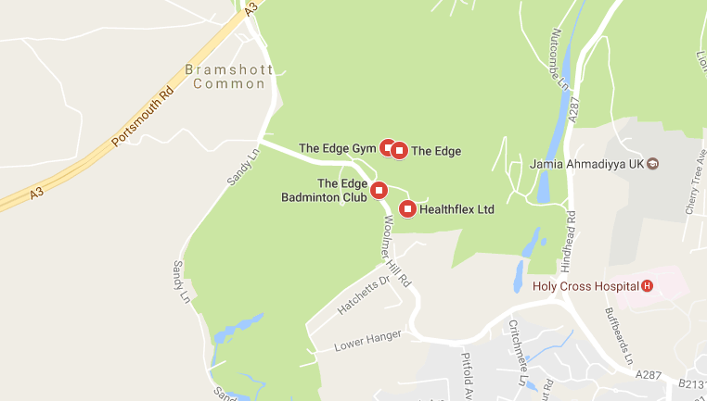
- Haslemere Leisure Centre, Kings Road, Haslemere, GU27 2AS - Capacity 350 – (Capacity for sleeping 150)
OS Grid Reference SU8832NE – What3Words – unscathed.runs.playfully
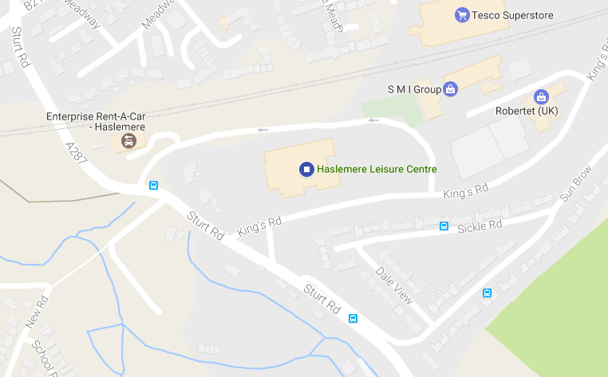

- Haslemere Hall, Bridge Road, Haslemere, GU27 2AS – Capacity 300
OS Grid Reference SU9033SW – What3Words – little.recover.clasping
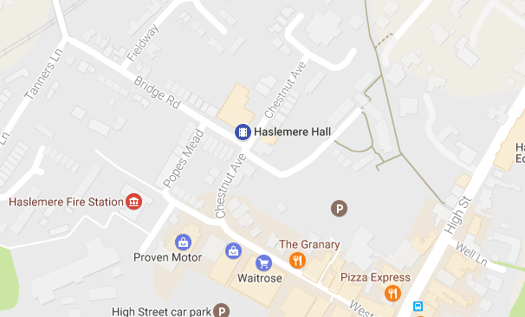
- Haslewey Community Centre, Lion Green, Haslemere, GU27 1LD – Capacity 150
OS Grid Reference SU8832NE – What3Words – protected.overused.nesting
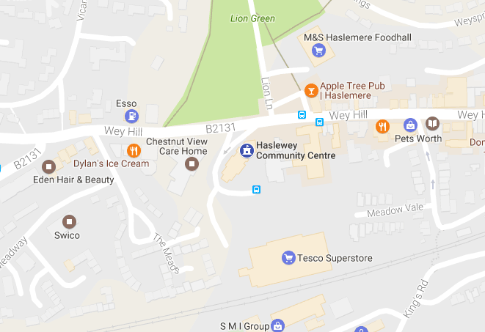
On present planning, Centres will be staffed by members of Waverley Borough Council, Surrey County Council, and voluntary organisations such as the Red Cross. Waverley Borough Council, will look to ensure the following resources are provided:- Camp Beds, Blankets, First aid equipment, Radio, Space heaters, Crockery, Toilet, Cutlery, Waste disposal bags, Bottled water and food, Care of pets.

HASLEMERE EMERGENCY SNOW PLAN

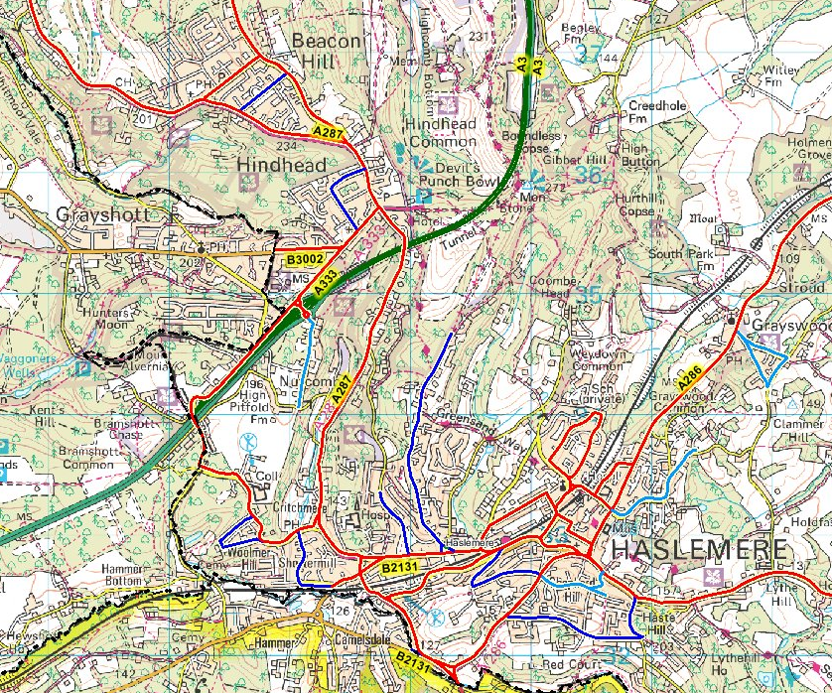

Priority 1 roads
Priority 1 roads are the most important roads in terms of the volume of traffic carried, and are the first to be treated in advance of any forecast frost, ice or snow. Priority 1 roads include:
- all A roads, B roads and roads carrying more than 8,000 vehicles per day
- main access routes to hospitals
- major bus routes
- roads that link salting routes with those of adjoining counties
- any priority 2 road which meets three or more of the criteria for priority 2 roads.

Priority 2 roads
During periods of prolonged and persistent frost, ice or snow, we extend salting to include these roads, but only once priority 1 roads have been cleared. Priority 2 roads include:
- roads carrying more than 4,000 vehicles per day
- main access routes to important industrial areas and secondary education establishments
- single access points to villages
- access roads leading to railway stations
- roads used by other bus routes and depots
- steep hazardous gradients and on bridges where local icing conditions are known to occur.

Any other road not indicated by a blue or red line is not part of SCC’s routine gritting schedule. These roads will have to make their own arrangements for gritting and snow clearance.

LOCATION OF GRIT BINS IN AND AROUND HASLEMERE
Asset ID | Road | Location | Town/Village
Surrey County Council’s
5630 | Whitmore Vale Road | A third of the way down the hill from A287 towards Grayshott | Hindhead
5631 | Whitmore Vale Road | Halfway down the hill from A287 towards Grayshott | Hindhead
5829 | Clovelly Road | Outside Creefleet House, approach to Tilford Road | Hindhead
5621 | Linkside South | Junction with Clovelly Road | Hindhead
5831 | Glen Close | Side of No. 9 | Hindhead
5626 | Steepways | 3/4 way down hill on the left hand side | Hindhead
6006 | Fairways | junction with Grove Road | Hindhead
5623 | Pine Bank | At the junction | Hindhead
5624 | Pine Bank | Left hand side at the junction | Hindhead
5625 | Rozeldene | At the junction | Hindhead
5629 | Tyndalls | Opposite No. 7 | Hindhead
5628 | The Moorings | Opposite No. 12 | Hindhead
5627 | The Moorings | Outside No. 26 | Hindhead
5590 | Kingswood Lane | Opposite to No. 1 | Haslemere
5602 | Lion Lane | Near Hindhead Road | Haslemere
6204 | High Pitfold | Opposite "Glenlea" 100m west of junction with Hazel Grove | Haslemere
5578 | Glen Lea | Junction with Hazel Grove/High Pitfold | Haslemere
5806 | Whitfield Road | Outside No. 25 | Haslemere
5599 | Peperham Road | Opposite No. 19 | Haslemere
6102 | Chatsworth Avenue | Outside No. 61 | Haslemere
5600 | Pine View Close | Junction with High Lane | Haslemere
5563 | Bunch Lane | North of junction with Stoatley Hollow | Haslemere
5843 | Stoatley Rise | Junction with Bunch Lane | Haslemere
5613 | The Paddock | Outside No. 1 "Paddock Corner" next to post box | Haslemere
5612 | The Avenue | Junction with Lion Lane | Haslemere
5565 | Cherry Tree Avenue | Opposite No. 64, access road to garages | Haslemere
5581 | Hatchetts Drive | 50m from Rackfield | Haslemere
5603 | Rackfield | Entrance to close | Haslemere
5618 | Woolmer Hill Road | Opposite junction with Hatchetts Drive | Haslemere
5958 | Critchmere Hill | 30m down from the A287 on the small spur of Critchmere hill | Haslemere
5601 | Pitfold Avenue | Near Woolmer Hill | Haslemere
5576 | Fir Tree Avenue | Shortly before bend | Haslemere
5611 | Sunvale Avenue | Junction with Sunvale Close | Haslemere
5575 | Dolphin Close | At the top end | Haslemere
5572 | Critchmere Lane | Near Border Road | Haslemere
5594 | Mill Close | Opposite No. 22, on bend | Haslemere
5574 | Trout Road | Junction with Deepdene | Haslemere
5583 | Herondale | Shortly before bend | Haslemere
5573 | Deepdene | Junction with Hindhead Road | Haslemere
5586 | Buffbeards Lane | Junction with Hindhead Road (opposite Deepdene) | Haslemere
5608 | Stile Gardens | At the end | Haslemere
5617 | Weysprings | Near Farnham Lane | Haslemere
5775 | Bunch Lane | Junction with Farnham Lane | Haslemere
5592 | Lion Lane | Outside Haslewey Community Centre | Haslemere
5845 | St Christophers Road | Opposite No. 13. near footbridge | Haslemere
5589 | Kings Road | By Railway Bridge | Haslemere
5610 | Sturt Road | Outside Old Yard (just before Railway Bridge) | Haslemere
5609 | Sun Brow | Junction with Sturt Road | Haslemere
5801 | Sun Brow | Outside No. 1 On bend before junction with Dale View | Haslemere
5802 | Sun Brow | Opposite No. 43 (junction with Sickle Road) | Haslemere
5582 | Hedgehog Lane | Junction with Longdene Road | Haslemere
5570 | Courts Hill Road | Junction with Courts Mount Road | Haslemere
5562 | Bell Road | Junction with Midhurst Road | Haslemere
5606 | Scotlands Close | On bend | Haslemere
5605 | Scotlands Close | Junction with Scotland Lane | Haslemere
5566 | Chiltern Close | Junction with Scotland Lane | Haslemere
5587 | Holly Ridge | Near Midhurst Road | Haslemere
5585 | Hill Road | Junction with Midhurst Road | Haslemere
5604 | Sandrock | Near Lower Street | Haslemere
5607 | Shepherds Hill | Near Lower Street | Haslemere
5569 | College Hill | Opposite Hales Field | Haslemere
6046 | College Hill Terrace | Outside No 2, junction with College Hill | Haslemere
5567 | College Hill | Junction with Hill Road | Haslemere
5839 | Hill Road | Near junction with Museum Hill | Haslemere
5595 | Museum Hill | Junction with Hill Road | Haslemere
5596 | Museum Hill | Junction with Petworth Road (On Verge) | Haslemere
5580 | Haste Hill | 150m from Petworth Road | Haslemere
5957 | Church Lane | Just before railway bridge | Haslemere
5561 | Beech Road | Junction with Church Road | Haslemere
5842 | Grayswood Road | Junction with Beech Road | Haslemere
5844 | Chase Lane | Outside Woodpeckers | Haslemere
5840 | Haste Hill | Opposite junction with Tennysons Ridge | Haslemere
5588 | Kemnal Park | Junction with Three Gates Lane | Haslemere
5584 | Highercombe Road | Junction with A286 (Grayswood Road) | Haslemere
5558 | Sandy Lane | Junction with Highercombe Road | Grayswood
5614 | Three Gates Lane | On bend | Haslemere
5557 | Lower Road | Near Grayswood Road | Grayswood
5579 | Haslemere Road | Near Church (entrance to Grayswood farm) | Haslemere
Haslemere Town Council’s
HTC | London Road | Next to Café Twenty5 | Hindhead
HTC | A287 Beacon Hill | Between Steepways and Corry Road | Hindhead
HTC | Glen Road | Junction with Beacon Hill Road | Hindhead
HTC | Hill Road | Entrance to WBC car park | Hindhead

LOCATION OF SALT STOCKS
Haslemere Town Council provides stocks of salt which are held in the following locations:
Location | Number of bags and location of gritters
Hindhead / Beacon Hill – distributed to various locations: | 30  40
Post Office, Royal Parade, Hindhead | 10
Haslemere Public Toilets | 40

There are four manual gritters currently located
- Beacon Hill at the Post Office, Royal Parade
- Beacon Hill primary school, Beacon Hill
- Haslemere public toilets at Waitrose (2)

Nominated individuals will be in charge of these gritters and the salt stocks. In conjunction with SCC, HTC and the Chamber of Trade the pavements will be gritted.

Pavement gritting – areas the responsibility of SCC - Haslemere
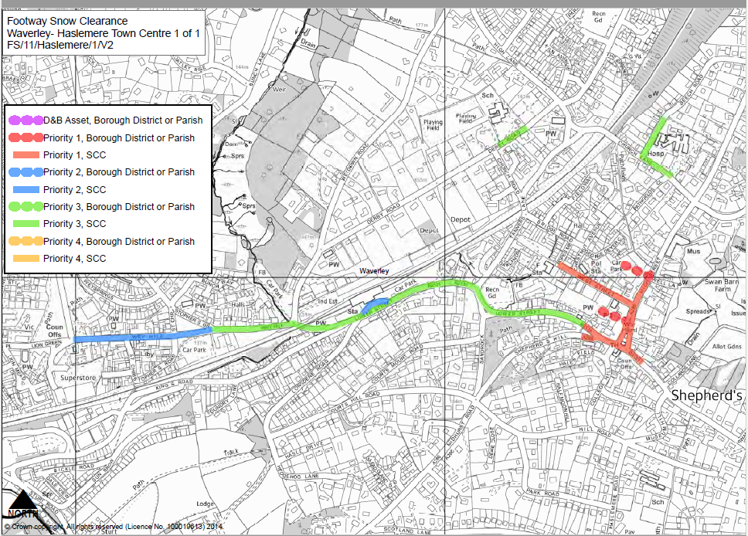

Pavement gritting – areas the responsibility of SCC – Beacon Hill
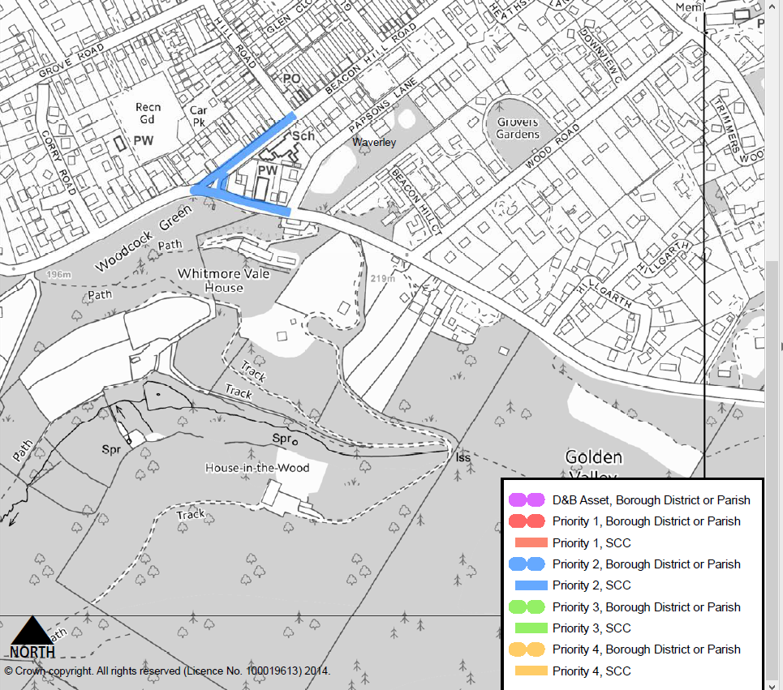

Location of Defibrillators in Grayswood, Haslemere and Hindhead

Defib Location | Description of location
Haslewey Community Centre Haslemere | GU27 1LD - Bottom of weyhill opposite Lion Green. |  | 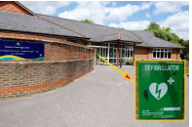
Comrades Club, Haslemere | 17 High Street, Haslemere, GU27 2HG |  | 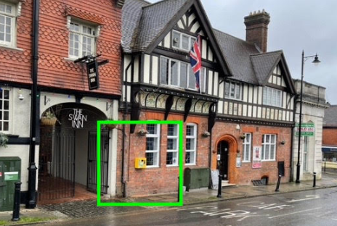  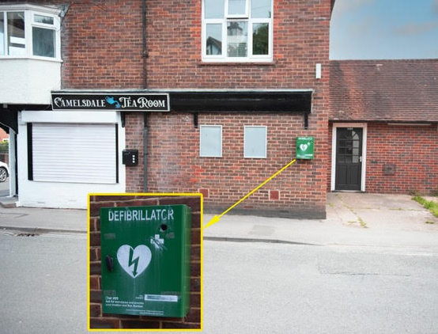  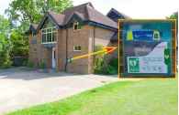
Tea room 126 Camelsdale | GU27 3RJ - On B2131 at junction of camelsdale rd and new rd
Grayswood Village Hall | GU27 2DJ - On A286 next to village hall opposite all saints church.
Katz auto services Critchmere Lane | GU27 1PR - Halfway down critchmere lane on right in front of the building. |  | 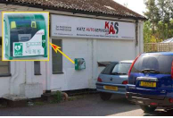  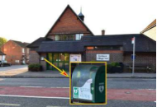
Fernhurst Village Hall | GU27 3EH - Glebe Midhurst road on left to main entrance
Waitrose Supermarket 41 West street | GU27 2AB - Haslemere on left going away from high street, on left to entrance |  | 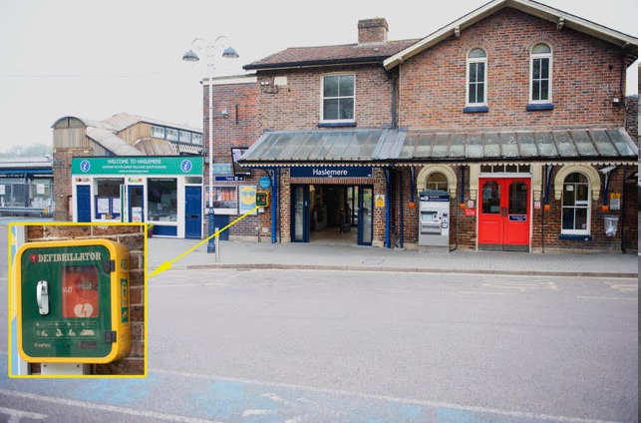  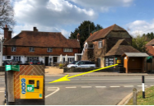  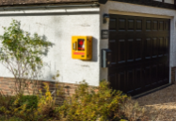  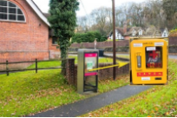  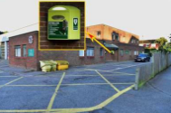  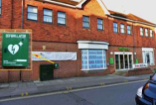  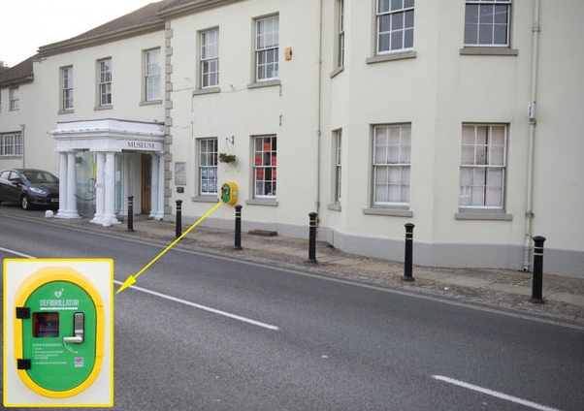
Haslemere Fire Station | GU27 2AP - West street, on left on door
Three Counties Church | GU27 3QB - Inside modern phone box on corner of Linchmere road
Timber gables Garage | GU27 3PT - Marley lane, Halway up hill from Arnolds
Dog and Pheasant pub | GU27 - On A286 at bus stop
Haslemere Railway Station | GU27 2PD - Lower street, left of main entrance
Haslemere Museum | 78 High St, Haslemere GU27 2LA
High Lane Community Centre |  | 19, Weycombe Road, Haslemere, Surrey. GU27 1EL |  | 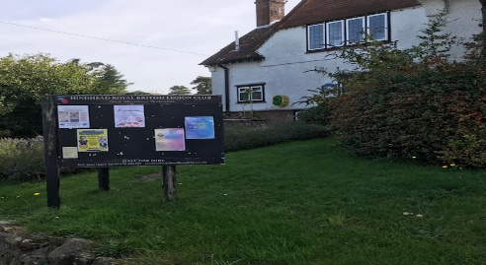  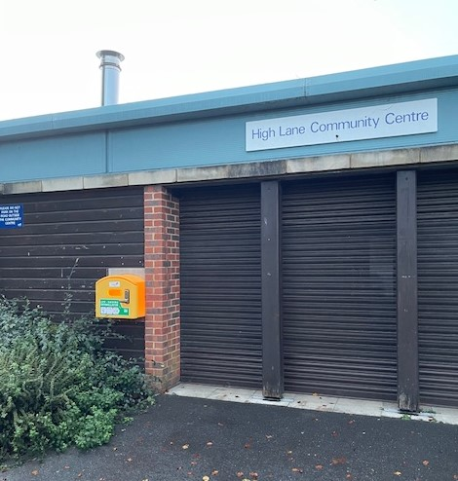
Beacon Hill Royal British Legion Club. |  | Beacon Hill Road, Beacon Hill, Hindhead GU26 6QB
PGL Beacon Hill |  | PGL Marchants Hill, Tilford Road, Beacon Hill, GU26 6RF Inside Centre Reception
Tesco Haslemere |  | Tesco supermarket, Lion Green, Haslemere, Surrey. |  | To be found in store along the corridor near the gents toilets

